**VISVESVARAYA TECHNOLOGICAL UNIVERSITY**

**JNANSANGAMA, BELAGAVI - 590018**

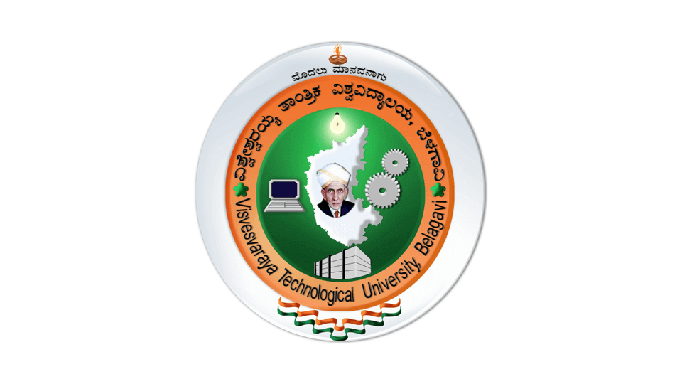

A Report on

**“ASSIGNMENT – 1”**

Submitted in partial fulfilment of the requirement for the award of the

Degree of Bachelor of Engineering

in

Information Science & Engineering

Submitted by

**Vidhya KK**

**1AT22IS120**

**Carried Out At**

**ATRIA INSTITUTE OF TECHNOLOGY**

**.**

**Guide:**

**Mrs. Shruthi**

**Assistant Professor**

**Atria Institute of Technology**



**ATRIA INSTITUTE OF TECHNOLOGY**

**Department of Information Science & Engineering**

**Anandnagar, Bangalore-560024**